A typical antibody is a ______molecule
A. X-shaped
B. Z-shaped
C. Y-shaped
D. U-shaped
ANSWER: C
The antibody molecule consists of ________polypeptide chains
A. One
B. two
C. three
D. four
ANSWER: D
The antibody molecule consists of __________identical long chains called heavy chains, and two identical short chains called light chains.
A. One
B. two
C. three
D. four
ANSWER: B
Each chain has a_________, a functional segment, and a variable segment
A. constant segment
B. Segment
C. Basic segment
D. Elementary segment
ANSWER: A
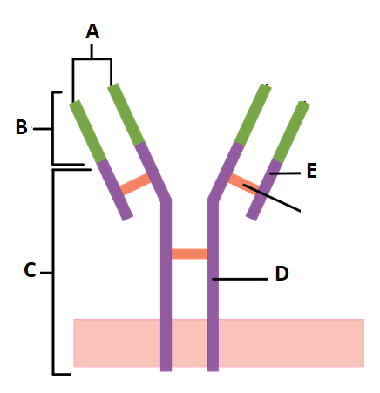
The given diagram shows the structure of:
A. Plasma membrane
B. T Cell
C. Antibody
D. Virus
ANSWER: C


Identify what A represents in the above diagram.
A. Antigen binding site
B. Constant region
C. Variable region
D. Light chain
ANSWER: A

Identify what B represents in the above diagram.
A. Antigen binding site
B. Constant region
C. Variable region
D. Light chain
ANSWER: C

Identify what C represents in the above diagram.
A. Antigen binding site
B. Constant region
C. Variable region
D. Light chain
ANSWER: B

Identify what D represents in the above diagram.
A. Heavy chain
B. Constant region
C. Variable region
D. Light chain
ANSWER: A

Identify what E represents in the above diagram.
A. Heavy chain
B. Constant region
C. Variable region
D. Light chain
ANSWER: D
Shape of antibody is
A. Z
B. W
C. T
D. Y
ANSWER: D
In humans and most mammals, an antibody unit consists of
A. one polypeptide chain
B. two polypeptide chains
C. four polypeptide chains
D. six polypeptide chains
ANSWER: C
In the structure of an antibody, there are _________identical heavy chains and two identical light chains connected by disulfide bonds
A. two
B. five
C. six
D. seven
ANSWER: A
Antibodies are ____ nm in size
A. 5
B. 10
C. 15
D. 20
ANSWER: B
Structurally an antibody is also partitioned into _______antigen-binding fragments
A. two
B. five
C. six
D. seven
ANSWER: A

